Assignment – 3
2. BMI Calculator
Code:
import java.util.Scanner;
class BMICalculator {
double height;
double weight;

public BMICalculator() {
}

public BMICalculator(double height, double weight) {
this.height = height;
this.weight = weight;
}

public double getHeight() {
return height;
}
public double getWeight() {
return weight;
}

public void setHeight(double height) {
this.height = height;
}
public void setWeight(double weight) {
this.weight = weight;
}

public double calculateBMI() {
return weight / (height * height);
}
}

class BMITest {
public static void main(String[] args) {
Scanner sc = new Scanner(System.in);

System.out.println("Enter height in m: ");
double height = sc.nextDouble();
System.out.println("Enter weight in kg: ");
double weight = sc.nextDouble();

BMICalculator bmiCalc = new BMICalculator();
bmiCalc.setHeight(height);
bmiCalc.setWeight(weight);

double bmi = bmiCalc.calculateBMI();
System.out.println("BMI: " + bmi);
}
}
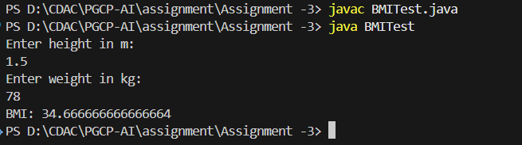

4. Electricity
Code:
import java.util.Scanner;

class ElectricityBill {
String customerName;
double unitsConsumed;
double billAmount;

public ElectricityBill(String customerName, double unitsConsumed) {
this.customerName = customerName;
this.unitsConsumed = unitsConsumed;
}

public void calculateBillAmount() {
if (unitsConsumed <= 100) {
this.billAmount = this.unitsConsumed * 5;
} else if (unitsConsumed <= 300) {
this.billAmount = 100 * 5 + (unitsConsumed - 100) * 7;
} else {
this.billAmount = 100 * 5 + 200 * 7 + (unitsConsumed - 300) * 10;
}
}

public void displayBill() {
System.out.println("Customer Name: " + customerName);
System.out.println("Units Consumed: " + unitsConsumed);
System.out.println("Total Bill Amount: Rs. " + billAmount);
}
}

class ElectricityCalc {
public static void main(String[] args) {
Scanner sc = new Scanner(System.in);
System.out.println("Enter customer name: ");
String Name = sc.next();
System.out.println("Enter units consumed: ");
double units = sc.nextDouble();

ElectricityBill e = new ElectricityBill(Name, units);
e.calculateBillAmount();
e.displayBill();
}
}
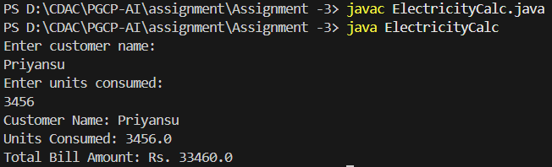

5. Telephone
Code:
import java.util.Scanner;

class TelephoneBill {

String customerName;
String phoneNumber;
int numberOfCalls;
float durationOfCalls;
float billAmount;

public TelephoneBill(String customerName, String phoneNumber, int numberOfCalls, float durationOfCalls)
{
this.customerName = customerName;
this.phoneNumber = phoneNumber;
this.numberOfCalls = numberOfCalls;
this.durationOfCalls = durationOfCalls;
}

public void calculateBill(){

float callCharge = 0;

float minDuration = durationOfCalls;
if (minDuration < 1) {
minDuration = 1;
}

if (numberOfCalls <= 100) {
callCharge = numberOfCalls * 0.50f;
} else {
callCharge = 100 * 0.50f + (numberOfCalls - 100) * 0.25f;
}

this.billAmount = 10 + callCharge;

}

public void displayBill(){
System.out.println("Customer Name: " + customerName);
System.out.println("Phone Number: " + phoneNumber);
System.out.println("Number of Calls: " + numberOfCalls);
System.out.println("Duration of Calls: " + durationOfCalls + " minutes");
System.out.println("Total Bill Amount:" + billAmount);

}
}

class TelephoneBillCalc {

public static void main(String[] args) {
Scanner sc = new Scanner(System.in);

System.out.println("Enter Customer Name: ");
String name = sc.nextLine();
System.out.println("Enter Phone Number: ");
String phone = sc.nextLine();
System.out.println("Enter Number of Calls Made: ");
int calls = sc.nextInt();
System.out.println("Enter Duration of Calls: ");
float duration = sc.nextFloat();

TelephoneBill teleBill = new TelephoneBill(name, phone, calls, duration);
teleBill.calculateBill();
teleBill.displayBill();

}

}

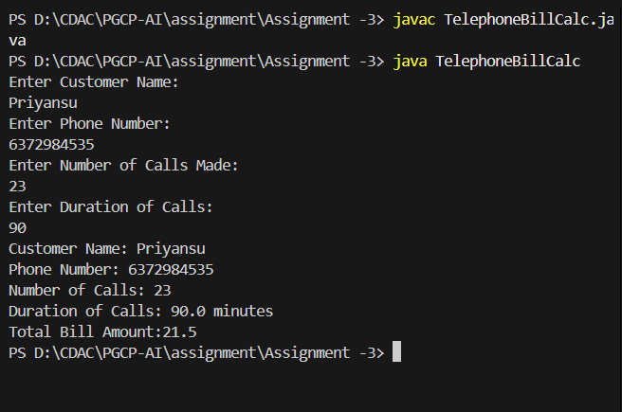
10. Credit Score Calculator
Code:
import java.util.Scanner;

class CreditScoreCalculator
{
int creditHistory;
double creditUtilization;

public CreditScoreCalculator()
{
this.creditHistory = 0;
this.creditUtilization = 0;
}

public CreditScoreCalculator(int creditHistory, double creditUtilization)
{
this.creditHistory = creditHistory;
this.creditUtilization = creditUtilization;
}

public void setCreditHistory(int creditHistory)
{
this.creditHistory = creditHistory;
}

public void setCreditUtilization(double creditUtilization)
{
this.creditUtilization = creditUtilization;
}

public int getCreditHistory()
{
return this.creditHistory;
}

public double getCreditUtilization()
{
return this.creditUtilization;
}

public int calculateCreditScore()
{
int creditScore;

if (this.creditUtilization < 30)
{
creditScore = (this.creditHistory * 15) + (int)(this.creditUtilization * 30) + 55;
}
else
{
creditScore = (this.creditHistory * 15) + (int)(this.creditUtilization * 30) + 35;
}

return creditScore;
}
}

class CreditScoreCalc
{
public static void main(String[] args)
{
Scanner sc = new Scanner(System.in);

System.out.println("Enter credit history: ");
int history = sc.nextInt();

System.out.println("Enter credit utilization percentage: ");
double utilization = sc.nextDouble();

CreditScoreCalculator csc = new CreditScoreCalculator(history, utilization);

int score = csc.calculateCreditScore();

System.out.println("Calculated Credit Score: " + score);
}
}
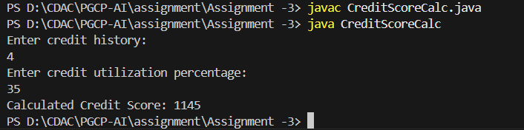
8. Rational Number;
Code:
import java.util.Scanner;

class RationalNumber
{
int numerator;
int denominator;

public RationalNumber(int numerator, int denominator)
{
this.numerator = numerator;
this.denominator = denominator;
}

public RationalNumber add(RationalNumber r)
{
int newNumerator = (this.numerator * r.denominator) + (r.numerator * this.denominator);
int newDenominator = this.denominator * r.denominator;
return simplify(newNumerator, newDenominator);
}

public RationalNumber subtract(RationalNumber r)
{
int newNumerator = (this.numerator * r.denominator) - (r.numerator * this.denominator);
int newDenominator = this.denominator * r.denominator;
return simplify(newNumerator, newDenominator);
}

public RationalNumber multiply(RationalNumber r)
{
int newNumerator = this.numerator * r.numerator;
int newDenominator = this.denominator * r.denominator;
return simplify(newNumerator, newDenominator);
}

public RationalNumber divide(RationalNumber r)
{
int newNumerator = this.numerator * r.denominator;
int newDenominator = this.denominator * r.numerator;
return simplify(newNumerator, newDenominator);
}

public RationalNumber simplify(int num, int den)
{
int smallest = num;
if (den < num)
{
smallest = den;
}

int gcd = 1;
for (int i = 1; i <= smallest; i++)
{
if (num % i == 0 && den % i == 0)
{
gcd = i;
}
}

num = num / gcd;
den = den / gcd;

return new RationalNumber(num, den);
}

public void display()
{
System.out.println(this.numerator + "/" + this.denominator);
}
}

class RationalNum
{
public static void main(String[] args)
{
Scanner sc = new Scanner(System.in);

System.out.println("Enter the first rational number:");
System.out.print("Numerator: ");
int num1 = sc.nextInt();
System.out.print("Denominator: ");
int den1 = sc.nextInt();

System.out.println("Enter the second rational number:");
System.out.print("Numerator: ");
int num2 = sc.nextInt();
System.out.print("Denominator: ");
int den2 = sc.nextInt();

System.out.print("Enter the arithmetic operation (+,-,*,/): ");
String op = sc.next();

RationalNumber r1 = new RationalNumber(num1, den1);
RationalNumber r2 = new RationalNumber(num2, den2);
RationalNumber result = new RationalNumber(0, 1);

if (op.equals("+"))
{
result = r1.add(r2);
}
else if (op.equals("-"))
{
result = r1.subtract(r2);
}
else if (op.equals("*"))
{
result = r1.multiply(r2);
}
else if (op.equals("/"))
{
result = r1.divide(r2);
}

System.out.print("Result: ");
result.display();
}
}
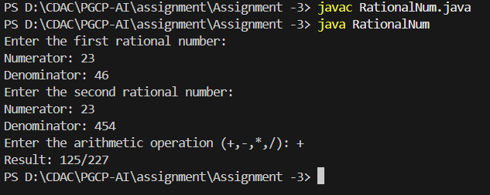

3. Book Manager:
Code:
import java.util.ArrayList;
import java.util.List;
import java.util.Scanner;

class Book {
private String title;
private String author;
private String publisher;
private String isbn;
private int year;
private double price;
private int quantity;

public Book() {
this.title = "Unknown";
this.author = "Unknown";
this.publisher = "Unknown";
this.isbn = "000-0000000000";
this.year = 0;
this.price = 0.0;
this.quantity = 0;
}

public Book(String title, String author, String publisher, String isbn, int year, double price, int quantity) {
this.title = title;
this.author = author;
this.publisher = publisher;
this.isbn = isbn;
this.year = year;
this.price = price;
this.quantity = quantity;
}

public String getTitle() { return title; }
public String getAuthor() { return author; }
public String getPublisher() { return publisher; }
public String getIsbn() { return isbn; }
public int getYear() { return year; }
public double getPrice() { return price; }
public int getQuantity() { return quantity; }

public void setTitle(String title) { this.title = title; }
public void setAuthor(String author) { this.author = author; }
public void setPublisher(String publisher) { this.publisher = publisher; }
public void setIsbn(String isbn) { this.isbn = isbn; }
public void setYear(int year) { this.year = year; }
public void setPrice(double price) { this.price = price; }
public void setQuantity(int quantity) { this.quantity = quantity; }

public void increaseQuantity(int quantity) {
if (quantity > 0) {
this.quantity += quantity;
System.out.println("Quantity increased. New quantity: " + this.quantity);
} else {
System.out.println("Increase amount must be greater than zero.");
}
}

public void decreaseQuantity(int quantity) {
if (quantity > 0 && quantity <= this.quantity) {
this.quantity -= quantity;
System.out.println("Quantity decreased. New quantity: " + this.quantity);
} else if (quantity > this.quantity) {
System.out.println("Not enough stock.");
} else {
System.out.println("Decrease amount must be greater than zero.");
}
}

public double getInventoryValue() {
return price * quantity;
}

public void displayBookInfo() {
System.out.println("Title: " + title);
System.out.println("Author: " + author);
System.out.println("Publisher: " + publisher);
System.out.println("ISBN: " + isbn);
System.out.println("Year: " + year);
System.out.println("Price: $" + price);
System.out.println("Quantity: " + quantity);
System.out.println("Inventory Value: $" + getInventoryValue());
}
}

public class BookManager {
private static List<Book> inventory = new ArrayList<>();
private static Scanner scanner = new Scanner(System.in);

public static void main(String[] args) {
inventory.add(new Book("Clean Code", "Robert C. Martin", "Prentice Hall", "9734567865", 2008, 657, 10));
inventory.add(new Book("The Pragmatic Programmer", "Andrew Hunt & David Thomas", "Addison-Wesley", "974545555555", 1999, 498, 7));
inventory.add(new Book("Introduction to Java", "Daniel Liang", "Pearson", "978454656446", 2021, 935, 15));

int choice;
do {
printMenu();
System.out.print("Enter choice: ");
choice = scanner.nextInt();
scanner.nextLine();
if (choice == 1) viewAllBooks();
else if (choice == 2) addBook();
else if (choice == 3) increaseStock();
else if (choice == 4) decreaseStock();
else if (choice == 5) viewInventoryValue();
else if (choice == 6) searchBook();
else if (choice == 0) System.out.println("Goodbye!");
else System.out.println("Invalid option. Try again.");
} while (choice != 0);
scanner.close();
}

private static void printMenu() {
System.out.println("\nBook Inventory System");
System.out.println("1. View All Books");
System.out.println("2. Add New Book");
System.out.println("3. Increase Book Quantity");
System.out.println("4. Decrease Book Quantity");
System.out.println("5. View Total Inventory Value");
System.out.println("6. Search Book by Title");
System.out.println("0. Exit");
}

private static void viewAllBooks() {
if (inventory.isEmpty()) {
System.out.println("No books in inventory.");
return;
}
for (int i = 0; i < inventory.size(); i++) {
System.out.println("Book #" + (i + 1));
inventory.get(i).displayBookInfo();
}
}

private static void addBook() {
System.out.println("Add New Book");
System.out.print("Title: "); String title = scanner.nextLine();
System.out.print("Author: "); String author = scanner.nextLine();
System.out.print("Publisher: "); String publisher = scanner.nextLine();
System.out.print("ISBN: "); String isbn = scanner.nextLine();
System.out.print("Year: "); int year = scanner.nextInt();
System.out.print("Price: "); double price = scanner.nextDouble();
System.out.print("Quantity: "); int quantity = scanner.nextInt();
scanner.nextLine();
Book newBook = new Book(title, author, publisher, isbn, year, price, quantity);
inventory.add(newBook);
System.out.println("Book added!");
newBook.displayBookInfo();
}

private static void increaseStock() {
System.out.println("Increase Book Quantity");
Book book = selectBook();
if (book == null) return;
System.out.print("Units to add: ");
int qty = scanner.nextInt();
scanner.nextLine();
book.increaseQuantity(qty);
}

private static void decreaseStock() {
System.out.println("Decrease Book Quantity");
Book book = selectBook();
if (book == null) return;
System.out.print("Units to remove: ");
int qty = scanner.nextInt();
scanner.nextLine();
book.decreaseQuantity(qty);
}

private static void viewInventoryValue() {
System.out.println("Inventory Value Report");
double totalValue = 0;
for (Book book : inventory) {
double val = book.getInventoryValue();
System.out.println(book.getTitle() + " - " + val + " (Qty: " + book.getQuantity() + ")");
totalValue += val;
}
System.out.println("Total Inventory Value: " + totalValue);
}

private static void searchBook() {
System.out.print("Enter title to search: ");
String keyword = scanner.nextLine().toLowerCase();
boolean found = false;
for (Book book : inventory) {
if (book.getTitle().toLowerCase().contains(keyword)) {
book.displayBookInfo();
found = true;
}
}
if (!found) System.out.println("No book found with that title.");
}

private static Book selectBook() {
if (inventory.isEmpty()) {
System.out.println("No books available.");
return null;
}
for (int i = 0; i < inventory.size(); i++) {
System.out.println((i + 1) + ". " + inventory.get(i).getTitle());
}
System.out.print("Select book number: ");
int index = scanner.nextInt() - 1;
scanner.nextLine();
if (index < 0 || index >= inventory.size()) {
System.out.println("Invalid selection.");
return null;
}
return inventory.get(index);
}
}
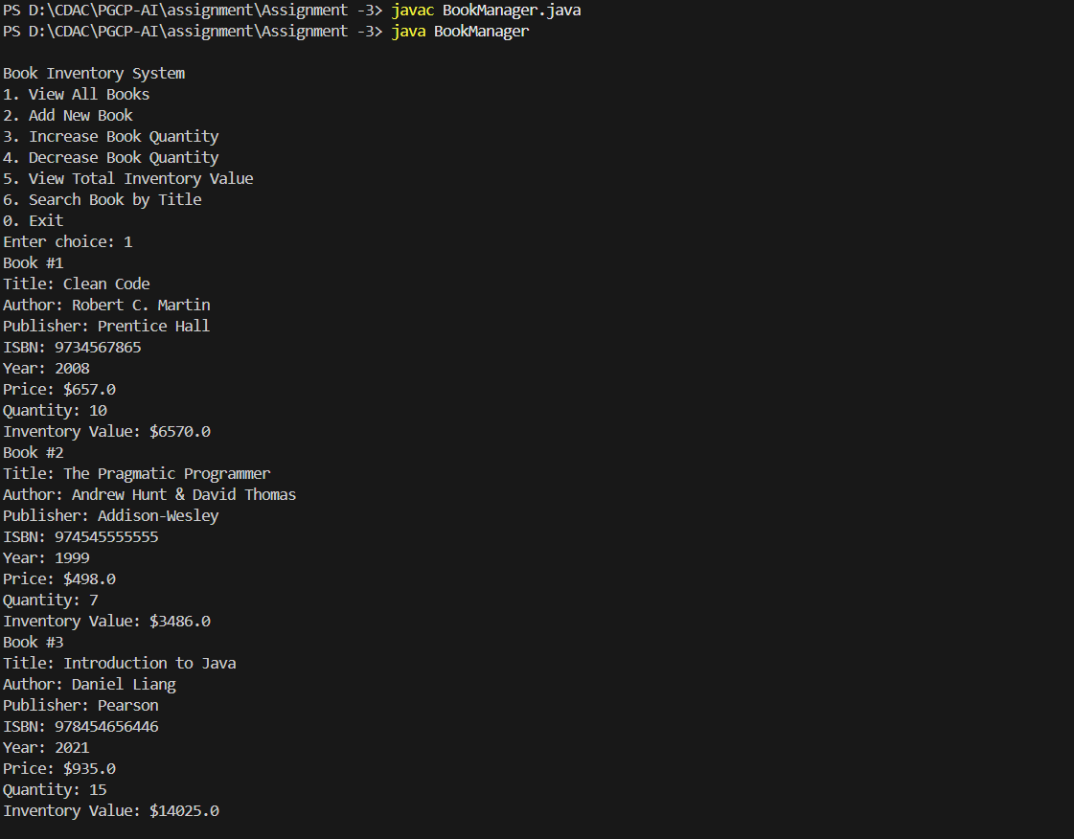

6. Bank Manager:
Code:
import java.util.Scanner;
class BankAccount {
String name;
int accountNumber;
double balance;

BankAccount(String name, int accountNumber) {
this.name = name;
this.accountNumber = accountNumber;
this.balance = 0;
}
void deposit(double amount) {
this.balance = this.balance + amount;
System.out.println("Deposit successful");
}
void withdraw(double amount) {
if (amount <= this.balance) {
this.balance = this.balance - amount;
System.out.println("Withdrawal successful");
}
else {
System.out.println("Insufficient balance");
}
}
void displayBalance() {
System.out.println("Current Balance: " + this.balance);
}
void displayInfo() {
System.out.println("Account Holder Name: " + this.name);
System.out.println("Account Number: " + this.accountNumber);
System.out.println("Balance: " + this.balance);
}
}
public class BankManager {
public static void main(String[] args) {

Scanner sc = new Scanner(System.in);
BankAccount account = null;
int nextAccountNumber = 1001;
int choice;
do {
System.out.println("\n1. Create Account");
System.out.println("2. Deposit");
System.out.println("3. Withdraw");
System.out.println("4. Check Balance");
System.out.println("5. Display Account Info");
System.out.println("6. Exit");
System.out.print("Enter your choice: ");
choice = sc.nextInt();
sc.nextLine();
switch (choice) {
case 1:
System.out.print("Enter Account Holder Name: ");
String name = sc.nextLine();
account = new BankAccount(name, nextAccountNumber);
System.out.println("Account created successfully");
System.out.println("Your Account Number is: " + nextAccountNumber);
nextAccountNumber++;
break;

case 2:
if (account == null) {
System.out.println("No account found");
}
else {
System.out.print("Enter Account Number: ");
int accNo = sc.nextInt();
if (accNo == account.accountNumber) {
System.out.print("Enter amount to deposit: ");
double amount = sc.nextDouble();
account.deposit(amount);
} else {
System.out.println("Invalid account number");
}
}
break;
case 3:
if (account == null) {
System.out.println("No account found");
}
else {
System.out.print("Enter Account Number: ");
int accNo = sc.nextInt();
if (accNo == account.accountNumber) {
System.out.print("Enter amount to withdraw: ");
double amount = sc.nextDouble();
account.withdraw(amount);
} else {
System.out.println("Invalid account number");
}
}
break;
case 4:
if (account == null) {
System.out.println("No account found");
} else {
System.out.print("Enter Account Number: ");
int accNo = sc.nextInt();
if (accNo == account.accountNumber) {
account.displayBalance();
}
else {
System.out.println("Invalid account number");
}
}
break;
case 5:
if (account == null) {
System.out.println("No account found");
}
else {
System.out.print("Enter Account Number: ");
int accNo = sc.nextInt();
if (accNo == account.accountNumber) {
account.displayInfo();
} else {
System.out.println("Invalid account number");
}
}
break;
case 6:
System.out.println("Thank you");
break;
default:
System.out.println("Invalid choice");
}
} while (choice != 6);
}
}

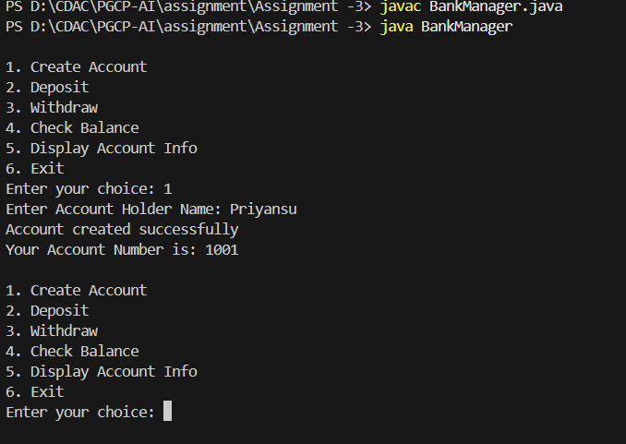

7. Toll Booth:
Code:
import java.util.Scanner;
class TollBooth {
String vehicleType;
int numAxles;
double distanceTraveled;
private double tollFee;
private double totalAmountDue;
void calculateTollFee() {
if (vehicleType.equalsIgnoreCase("truck")) {
tollFee = 0.50 * numAxles * distanceTraveled;
}
else {
tollFee = 0.25 * numAxles * distanceTraveled;
}
totalAmountDue = tollFee + 2.00;
System.out.println("Toll fee calculated successfully");
}
void generateBill() {
if (tollFee == 0) {
System.out.println("Please calculate toll fee first");
return;
}
System.out.println("\n----- Toll Booth Bill -----");
System.out.println("Vehicle Type: " + vehicleType);
System.out.println("Number of Axles: " + numAxles);
System.out.println("Distance Travelled: " + distanceTraveled + " miles");
System.out.printf("Toll Fee: %.2f\n", tollFee);
System.out.println("Processing Fee: 2.00");
System.out.printf("Total Amount Due: %.2f\n", totalAmountDue);
}
static void showMenu() {
System.out.println("\n1. Enter Vehicle Type (car, van, bus, truck)");
System.out.println("2. Enter Number of Axles");
System.out.println("3. Enter Distance Travelled");
System.out.println("4. Calculate Toll Fee");
System.out.println("5. Generate Bill");
System.out.println("6. Exit");
System.out.print("Enter your choice: ");
}
}
public class Toll {
public static void main(String[] args) {
Scanner sc = new Scanner(System.in);
TollBooth toll = new TollBooth();
int choice;
do {
TollBooth.showMenu();
choice = sc.nextInt();
sc.nextLine();
switch (choice) {
case 1:
System.out.print("Enter vehicle type: ");
toll.vehicleType = sc.nextLine();
break;
case 2:
System.out.print("Enter number of axles: ");
toll.numAxles = sc.nextInt();
break;

case 3:
System.out.print("Enter distance travelled (in miles): ");
toll.distanceTraveled = sc.nextDouble();
break;
case 4:
toll.calculateTollFee();
break;
case 5:
toll.generateBill();
break;
case 6:
System.out.println("Thank you");
break;
default:
System.out.println("Invalid choice");
}
} while (choice != 6);
sc.close();
}
}

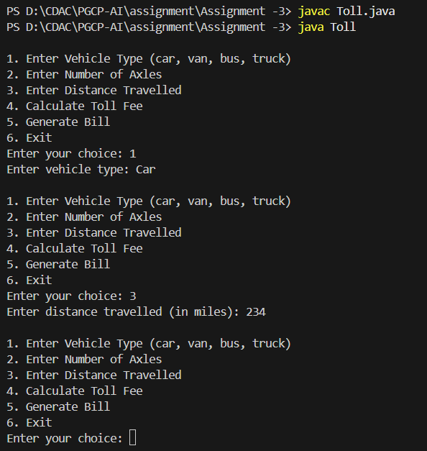

9. Date:
code:
import java.util.Scanner;
class DateMethods {
int day;
int month;
int year;
DateMethods(int d, int m, int y) {
day = d;
month = m;
year = y;
}
public boolean isLeapYear() {
if (year % 400 == 0) {
return true;
} else if (year % 100 == 0) {
return false;
} else if (year % 4 == 0) {
return true;
} else {
return false;
}
}
public boolean isValid() {
if (year < 1 || month < 1 || month > 12 || day < 1) {
return false;
}
int[] days = {31, isLeapYear() ? 29 : 28, 31, 30, 31, 30, 31, 31, 30, 31, 30, 31};
if (day > days[month - 1]) {
return false;
}

return true;
}
public int getDayOfWeek() {
int d = day;
int m = month;
int y = year;
if (m < 3) {
m = m + 12;
y = y - 1;
}
int k = y % 100;
int j = y / 100;
int h = (d + (13 * (m + 1)) / 5 + k + (k / 4) + (j / 4) + (5 * j)) % 7;
int result = (h + 6) % 7;
return result;
}
public DateMethods getNextDay() {
int[] days = {31, isLeapYear() ? 29 : 28, 31, 30, 31, 30, 31, 31, 30, 31, 30, 31};
int nd = day + 1;
int nm = month;
int ny = year;
if (nd > days[month - 1]) {
nd = 1;
nm++;
if (nm > 12) {
nm = 1;
ny++;
}
}

return new DateMethods(nd, nm, ny);
}
public DateMethods getPreviousDay() {
int nd = day - 1;
int nm = month;
int ny = year;
if (nd < 1) {
nm--;
if (nm < 1) {
nm = 12;
ny--;
}
int[] days = {31, (ny % 400 == 0 || (ny % 4 == 0 && ny % 100 != 0)) ? 29 : 28,
31, 30, 31, 30, 31, 31, 30, 31, 30, 31};
nd = days[nm - 1];
}
return new DateMethods(nd, nm, ny);
}
public String toString() {
String d = (day < 10 ? "0" + day : "" + day);
String m = (month < 10 ? "0" + month : "" + month);
return d + "-" + m + "-" + year;
}
}
public class Date {
public static void main(String[] args) {
Scanner sc = new Scanner(System.in);

System.out.print("Enter day: ");
int d = sc.nextInt();
System.out.print("Enter month: ");
int m = sc.nextInt();
System.out.print("Enter year: ");
int y = sc.nextInt();
DateMethods date = new DateMethods(d, m, y);
System.out.println("Is the date valid? " + date.isValid());
System.out.println("Day of the week (0=Sunday ... 6=Saturday): " + date.getDayOfWeek());
System.out.println("Is it a leap year? " + date.isLeapYear());
DateMethods next = date.getNextDay();
System.out.println("Next day is: " + next);
DateMethods prev = date.getPreviousDay();
System.out.println("Previous day is: " + prev);
}
}

